July 7, 20022
NEW TEAM TO LEAD NEW ZEALAND’S LIBRARY AND INFORMATION ASSOCIATION - TE RAU HERENGA O AOTEAROA
Taking up the mantle as the new president of the Library and Information Association of New Zealand (LIANZA) from July 1 is Kim Taunga, Head of Community Delivery South at Auckland Council.
Kim’s father was born in Rarotonga and her mother has Irish whakapapa. She will be LIANZA’s first Pasifika president. A ceremony took place last week to bestow the presidential pounamu, which is worn by all presidents for their year in office, and welcome Kim and new president-elect Richard Misilei. The ceremony took place at Auckland Council’s newest library and community hub, Te Paataka Koorero o Takaanini which opened in March 2021.
Kim says, “Kia orana kōtou katoa, I am really pleased to be able to serve as the LIANZA Te Rau Herenga o Aotearoa president this year. I have been involved in the association since my first library assistant role in Manukau, straight out of my library studies at Victoria University of Wellington. The association has a 112-year history, and I am very aware of the responsibilities that come with this role and the many amazing librarians who have come before me.
“A key support group for me is the LIANZA Pacific Information Management Network. I expect to talanoa with groups across the library sector to understand how the association can help grow and strengthen the library profession and support librarians in their mahi.

“LIANZA has had a formal partnership with Te Rōpū Whakahau the national body that represents Māori engaged in libraries, culture, knowledge, information, communication and systems technology in Aotearoa New Zealand, since 1995. A focus for me this year will be strengthening and growing this important partnership. I have met so many great librarians and had such fun being involved in the library association that I hope I can give back just as much as I have gained from LIANZA.”

Richard Misilei (Richy) currently works as the Auckland Council Connected Communities Lead and Coach for the Ōtara-Papatoetoe area. A proud Samoan, Richy began his career in Manukau Libraries in 2007 after graduating from the University of Auckland. He was the first of his family to get a university degree.
Having risen through the ranks including a stint managing the Tupu Youth Library in Ōtara, he leads a talented and passionate team in the Connected Communities Department who are dedicated to sharing their love of literacy, the arts and engaging and empowering communities.
“I have been given so many opportunities to do things I would never have expected including speaking at conferences, writing a Pacific strategy, and convening the 2019 LIANZA conference,” says Richy. “Joining the LIANZA presidential team is another opportunity I’m looking forward to.”
Kim and Richy will be supported in their presidential roles by immediate past-president Erica Rankin, Community Libraries Manager, Christchurch Libraries.
Erica says, “This is exciting for LIANZA to welcome our first Pasifika president and president-elect. We want to acknowledge the LIANZA leaders who have paved the way for Kim and Richy, who have shown strong cultural inclusion in their leadership, people like our past-president Anahera Morehu. They contributed to us being a stronger and more representative body for our members.”
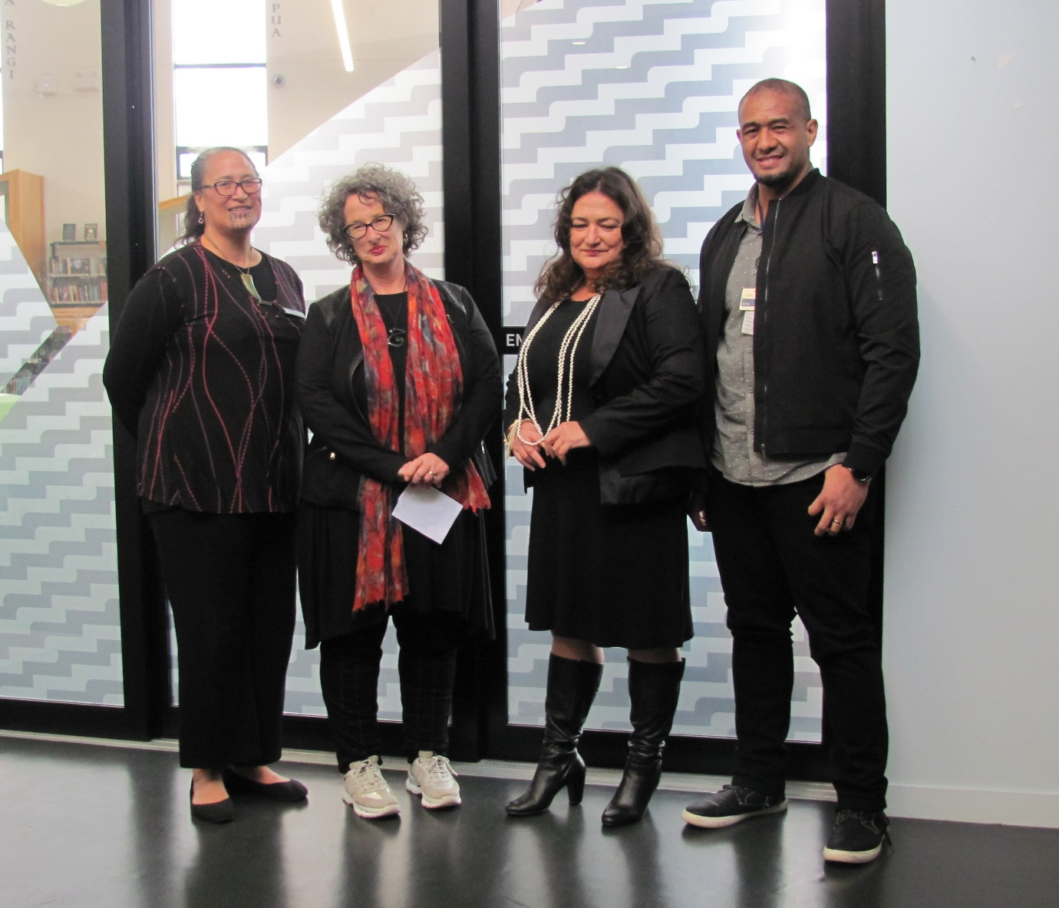
At the handing over to the new president are, from left, past-presidents Anahera Morehu (Ngāti Whātua Ōrākei) and Erica Rankin, Kim Taunga and Richy Misilei.
ABOUT LIANZA
The Library & Information Association of New Zealand Aotearoa: Te Rau Herenga o Aotearoa (LIANZA) is the professional organisation supporting the library and information sector in Aotearoa New Zealand, ensuring that New Zealanders have equitable access to world class innovative library services in all aspects of their lives, from school to university and from public to private sector. LIANZA represents around 1200 personal and institutional members from public, school, tertiary and special libraries. The association began in 1910. LIANZA is a member of the International Federation of Library Associations (IFLA). For further information about LIANZA visit http://www.lianza.org.nz/
FOR MORE INFORMATION CONTACT
LIANZA Communications Advisor, Angie Cairncross 0212228076

